Created by :

Hamza NOUAR

Yassine lamzouki

Intro:

**A dynamic school management System tool to handle necessary educational tasks, enrollments, applications and verifications.. SMS / Email notifications for Student Admission, Fees Submission, Exam Results, Absent Student, User…**



School Management System - Use Case Diagram

UML Use Case diagram for School Management System is shown below. The various

participants of the same are detailed below:-

**Actors**:- Admin, Teacher, Students

The corresponding use cases for these actors are:-

• **Admin:** Login, Logout, Add Teachers, Add Students, Add Class, Add Divisions, Add

Subjects, Modify/Delete Teachers, Modify/Delete Students, Modify/Delete Class,

Modify/Delete Divisions, Modify/Delete Subjects

• **Teacher:** Mark Attendance, Prepare Test Paper, Check Papers, Prepare Report

Cards, Declare Result

• **Student:** Fill Admission Form, Get Enrolled, Write Exams

The Use Case UML diagram for School Management System is shown below:-

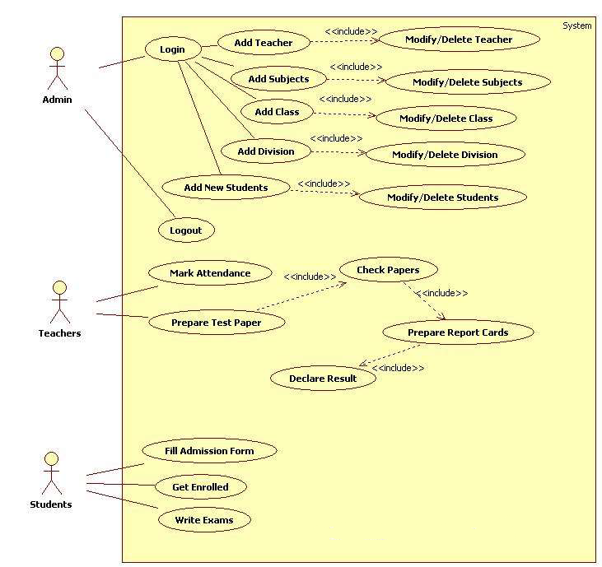

School Management System - Class Diagram

UML Class diagram for School Management System is shown below. The various Classes

involved in the system are:

**Classes**: Admin, Students, Teachers, Class, Subjects, Divisions, TestPaper

The Class Diagram for School Management System is shown below: 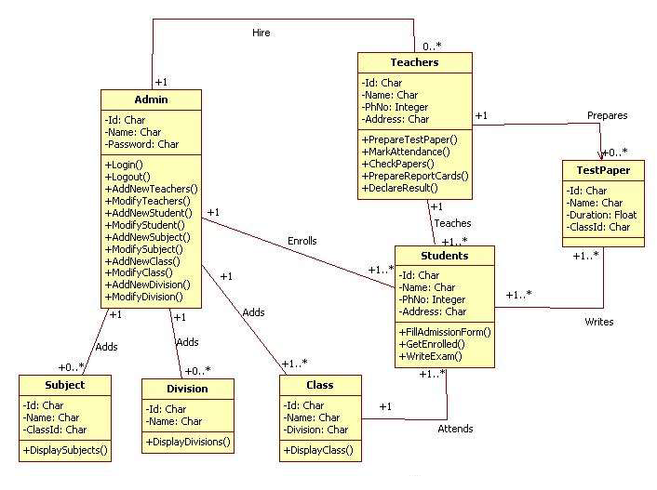

School Management System - Sequence Diagram

UML Sequence diagram for School Management System is shown below.

The instance of class objects involved in this UML Sequence Diagram are as follows:-

Admin, Teacher, Test Paper. Student, Class, Subject, Division

